18/12/2023

Chakradhar Bhogapurapu

OOPS concept

🡪Classes and Objects

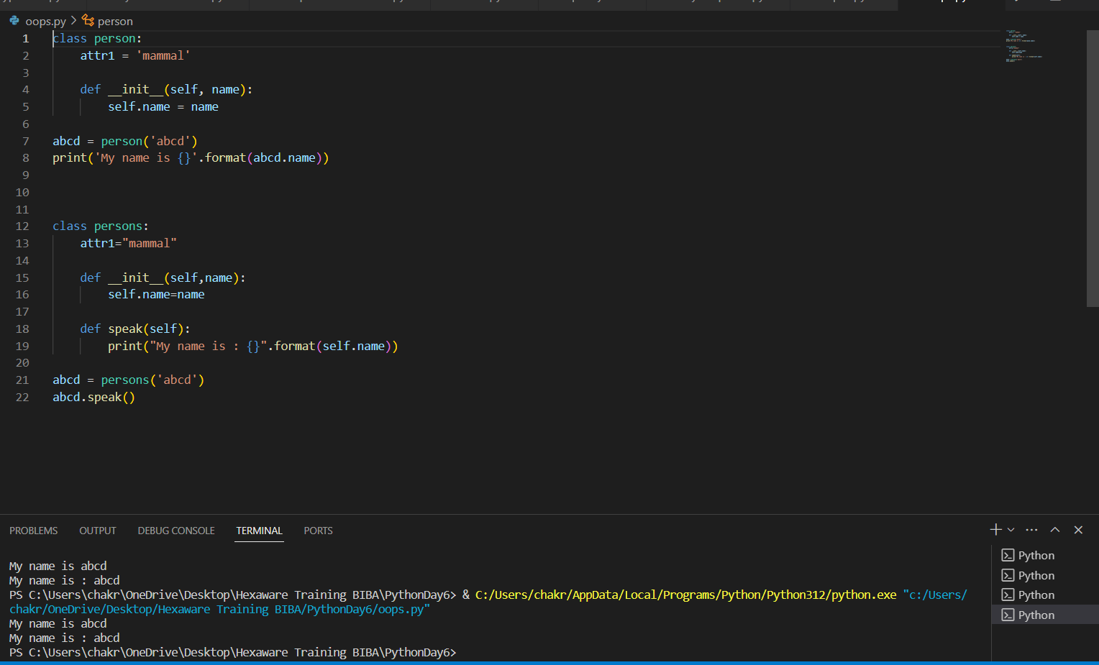

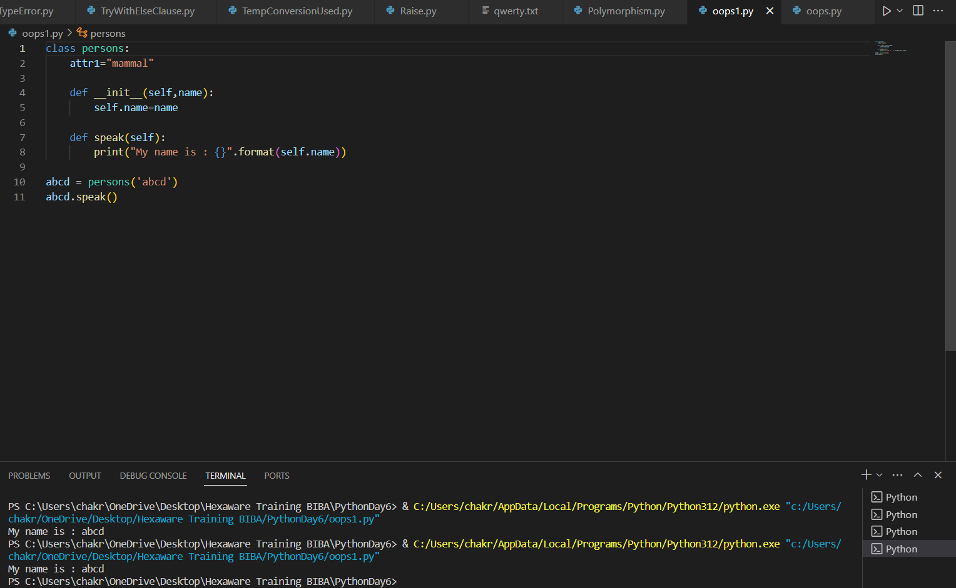

__init__() is a constructor in class. It will be initialized when ever the class is called.

It takes one default parameter known as self. Classes are accessed with objects.

🡪Inheritance

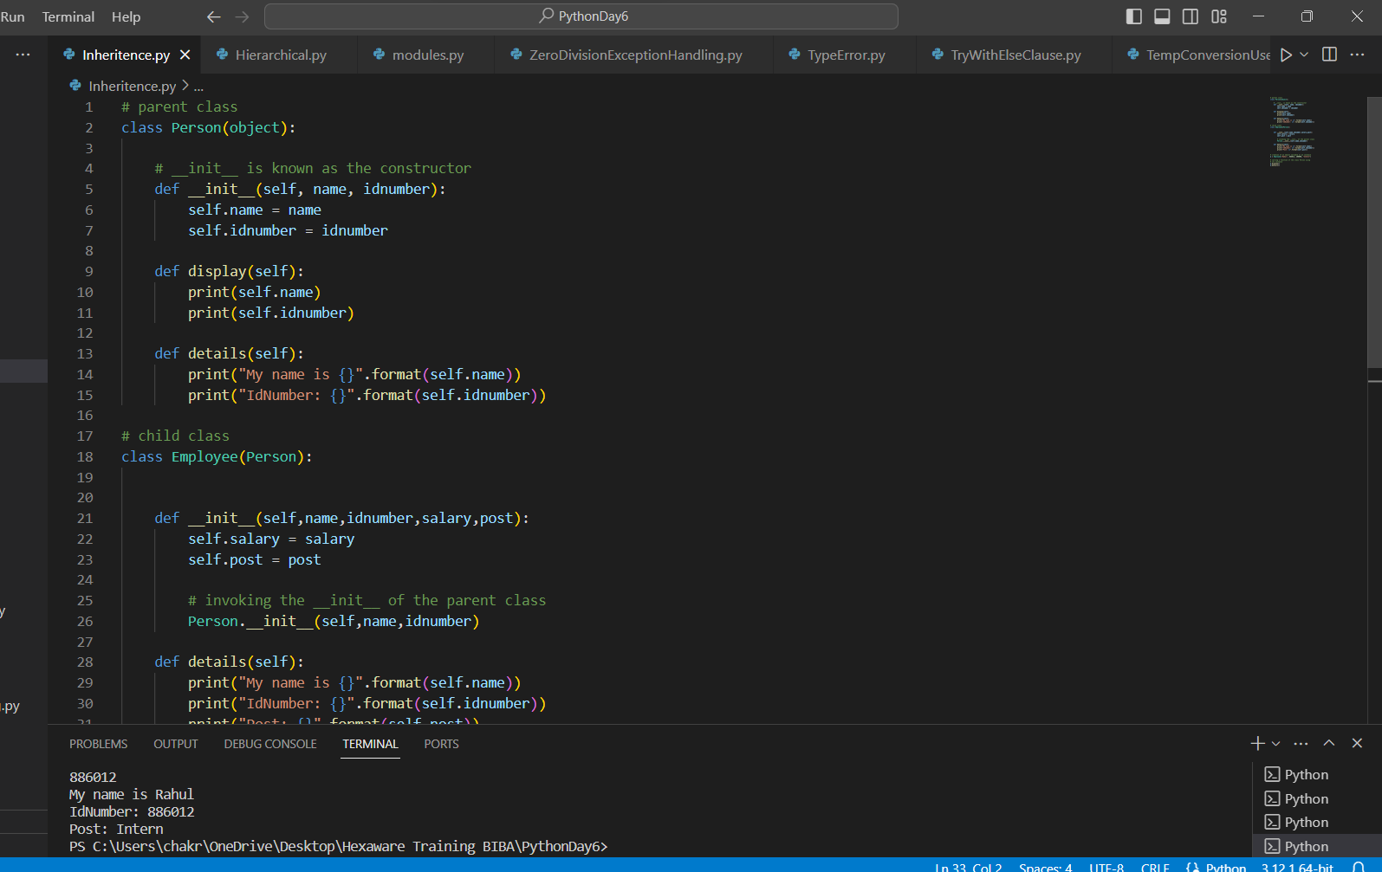

Transfer of properties i.e., objects and function from parent class to child class is known as Inheritance.

Types of inheritance

single level inheritance

Only one base class will be there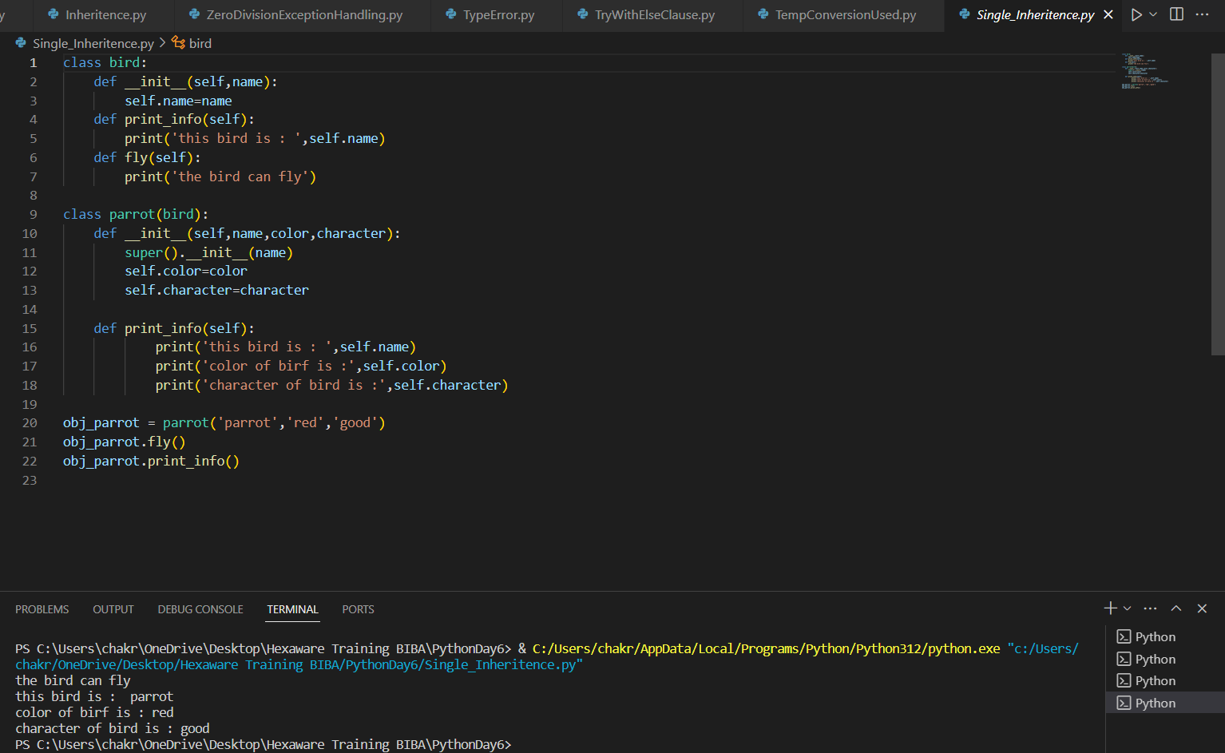

Multi level inheritance

A base class will be having another base class

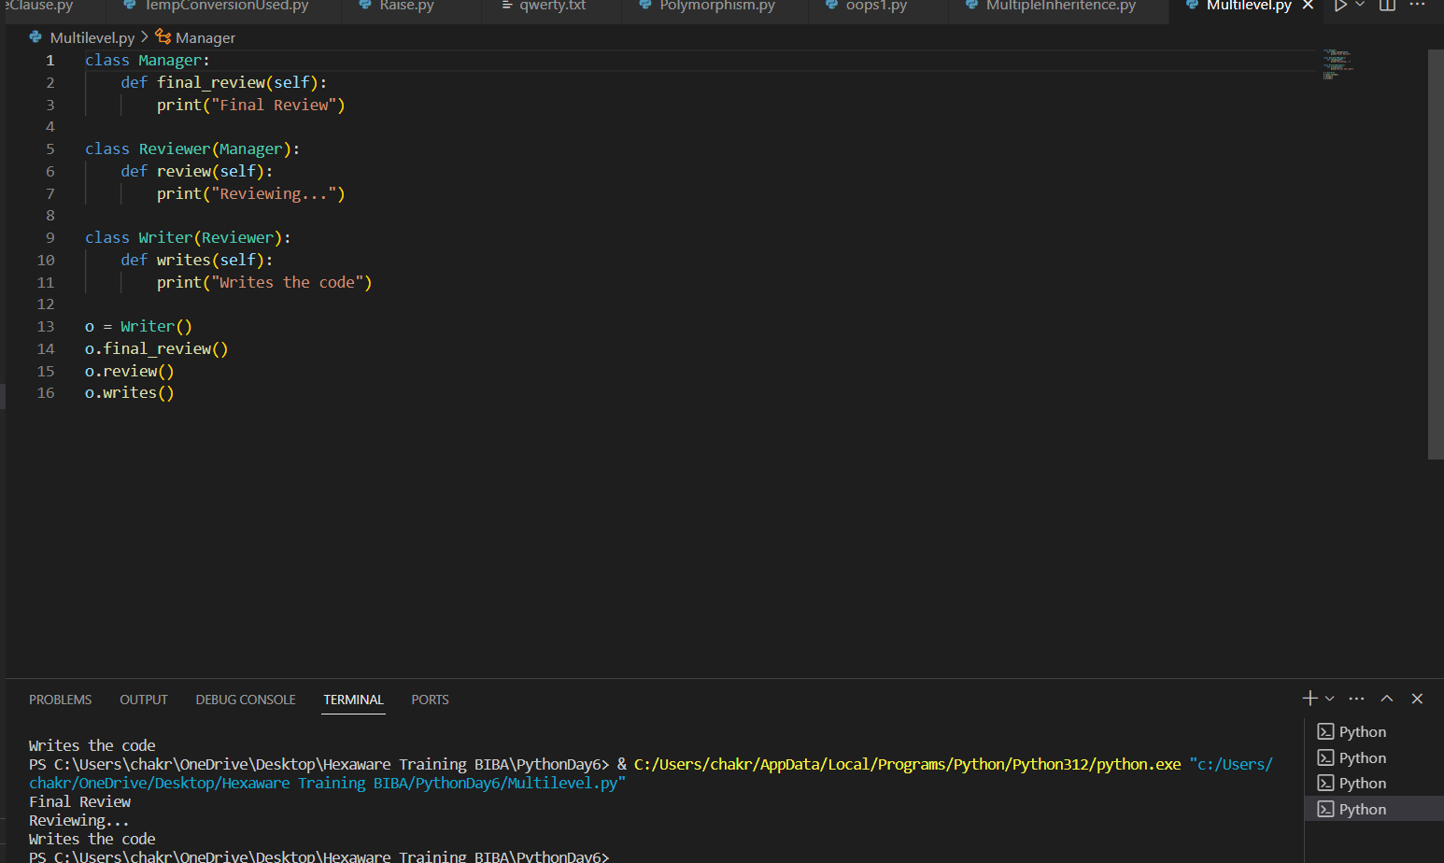

Multiple Inheritance

Multiple base classes will be there.

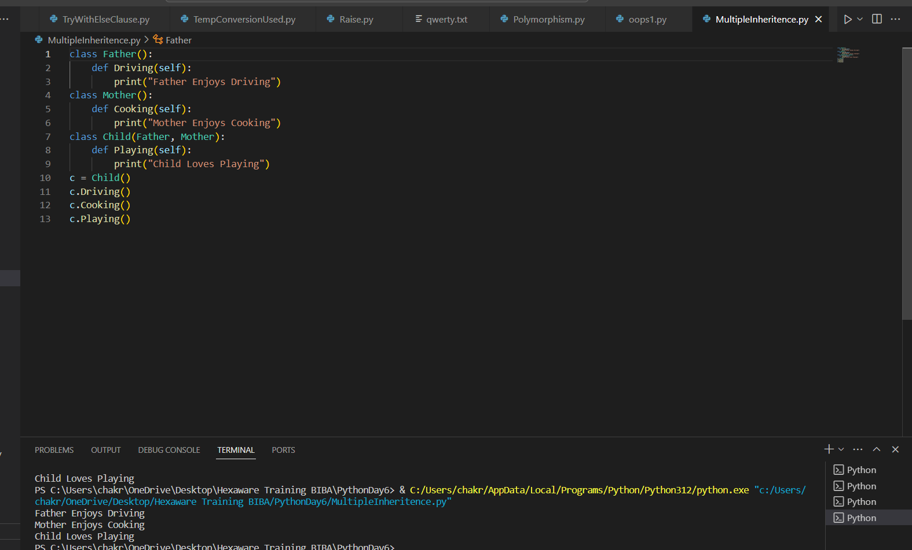

Hierarchal

More than one child cases will be there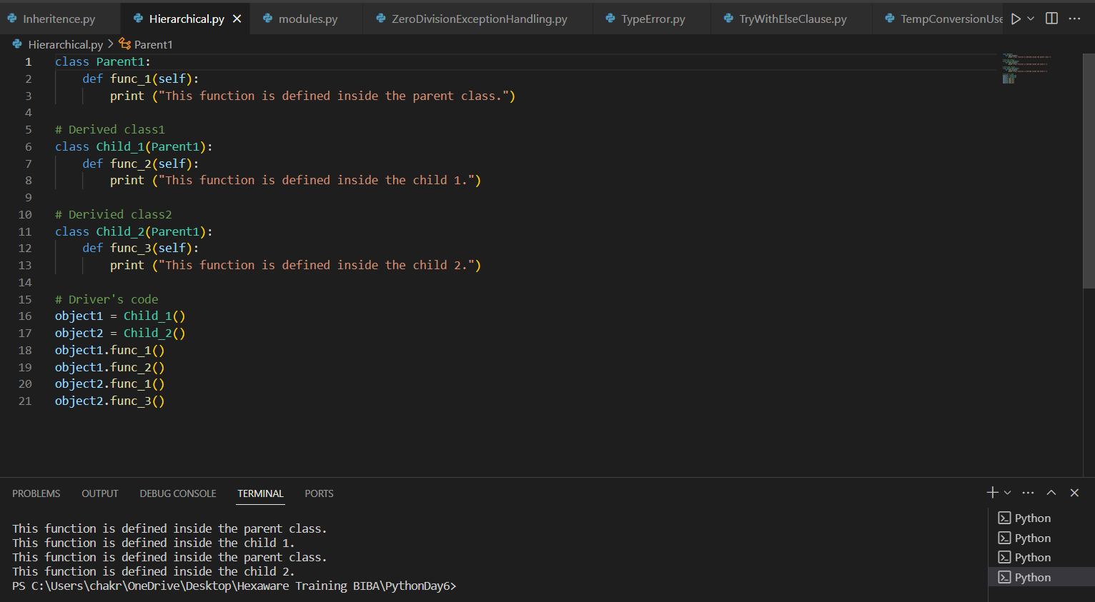

🡪Encapsulation

The ability of a message to be displayed in more than one form.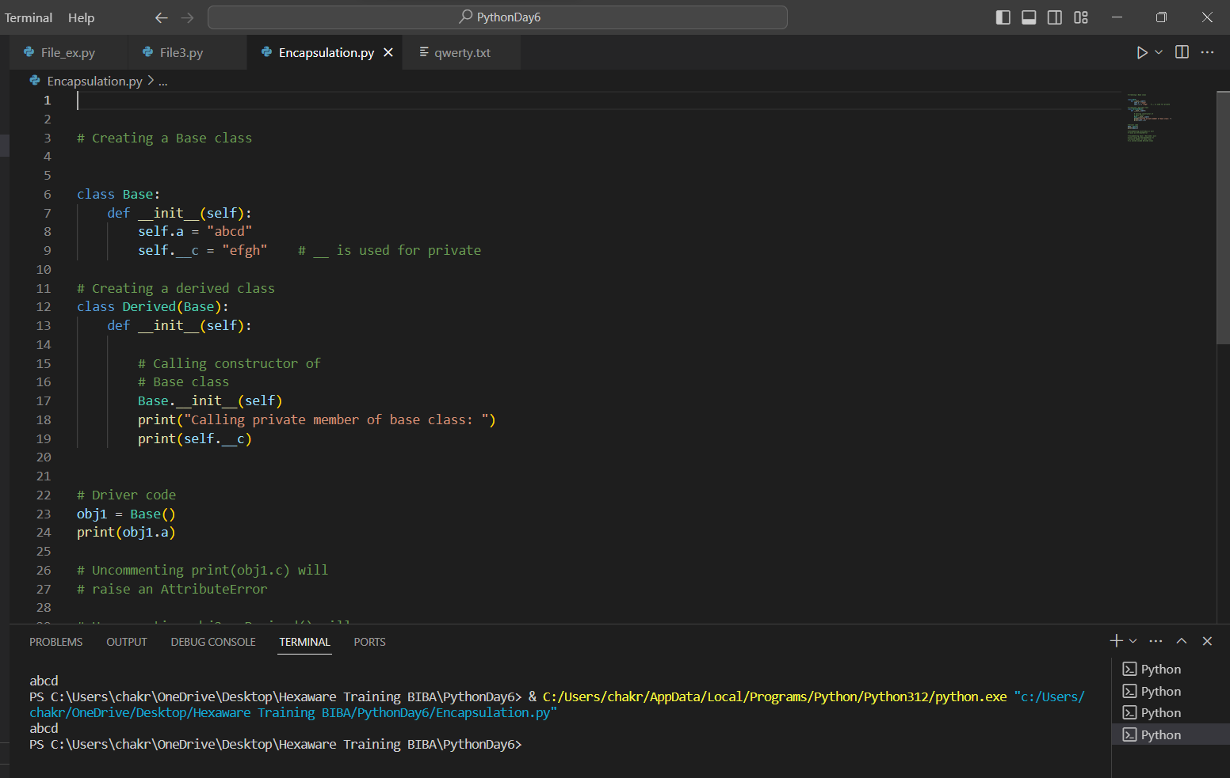

🡪Polymorphism

The entity in code such as variable, function or object can have more than one form.

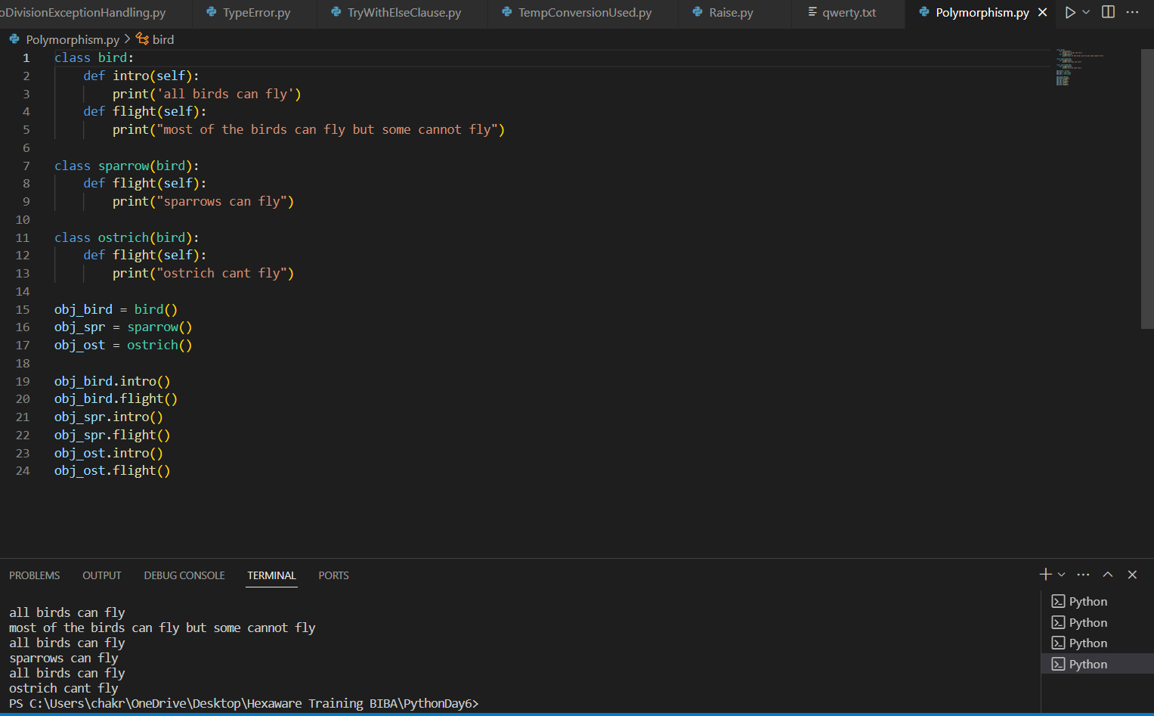

🡪Files

Read

It is used to read data from a file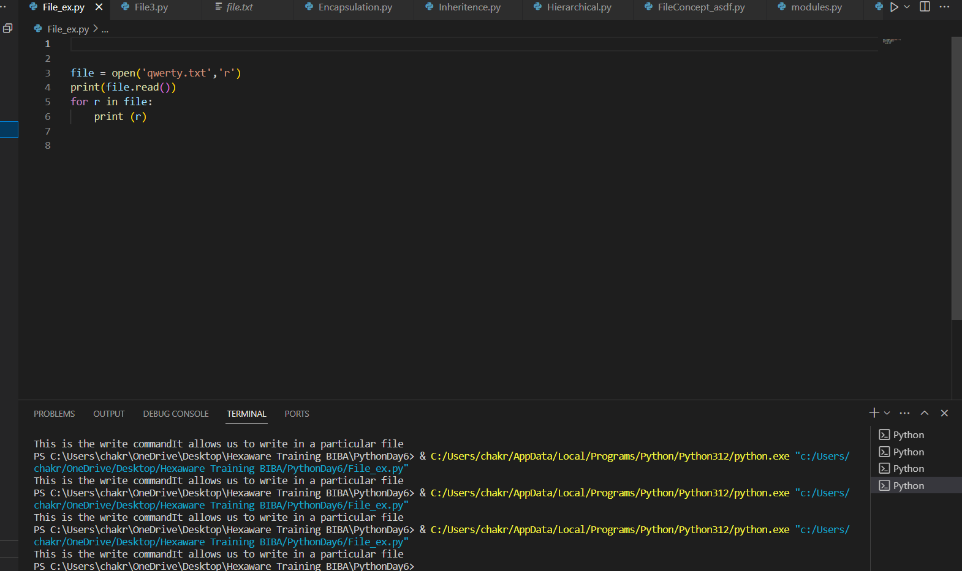

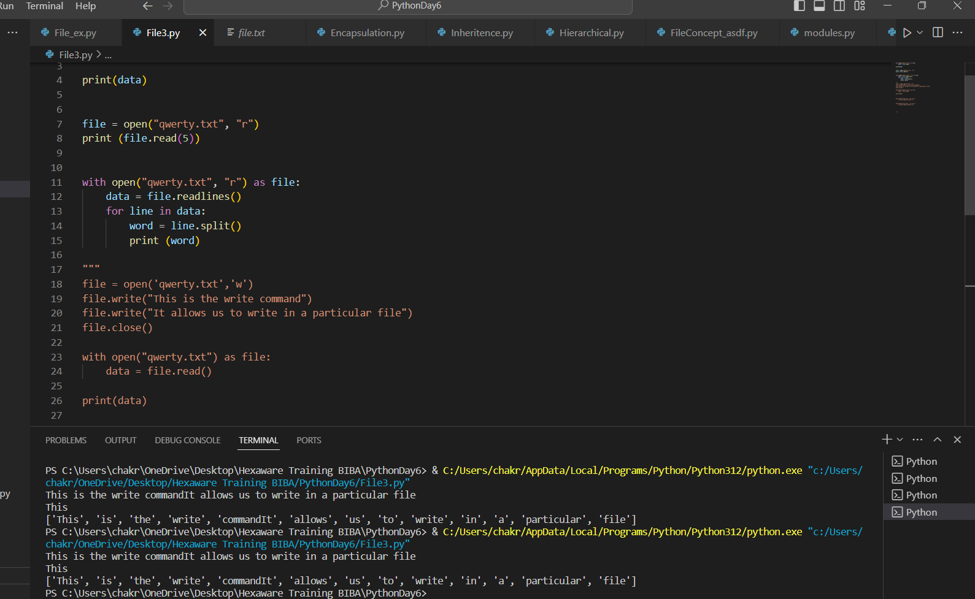

Write

It is used to write data into file.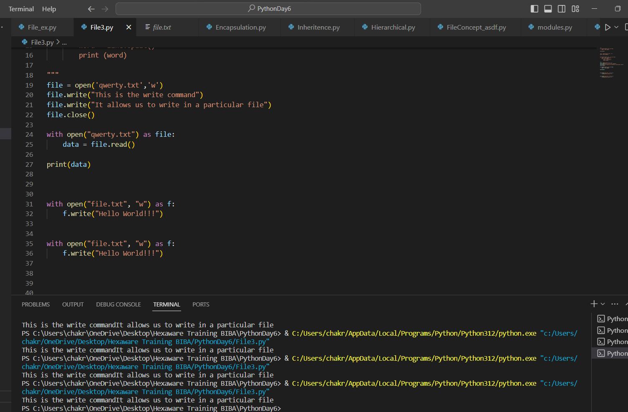

Append

It is used to append data into file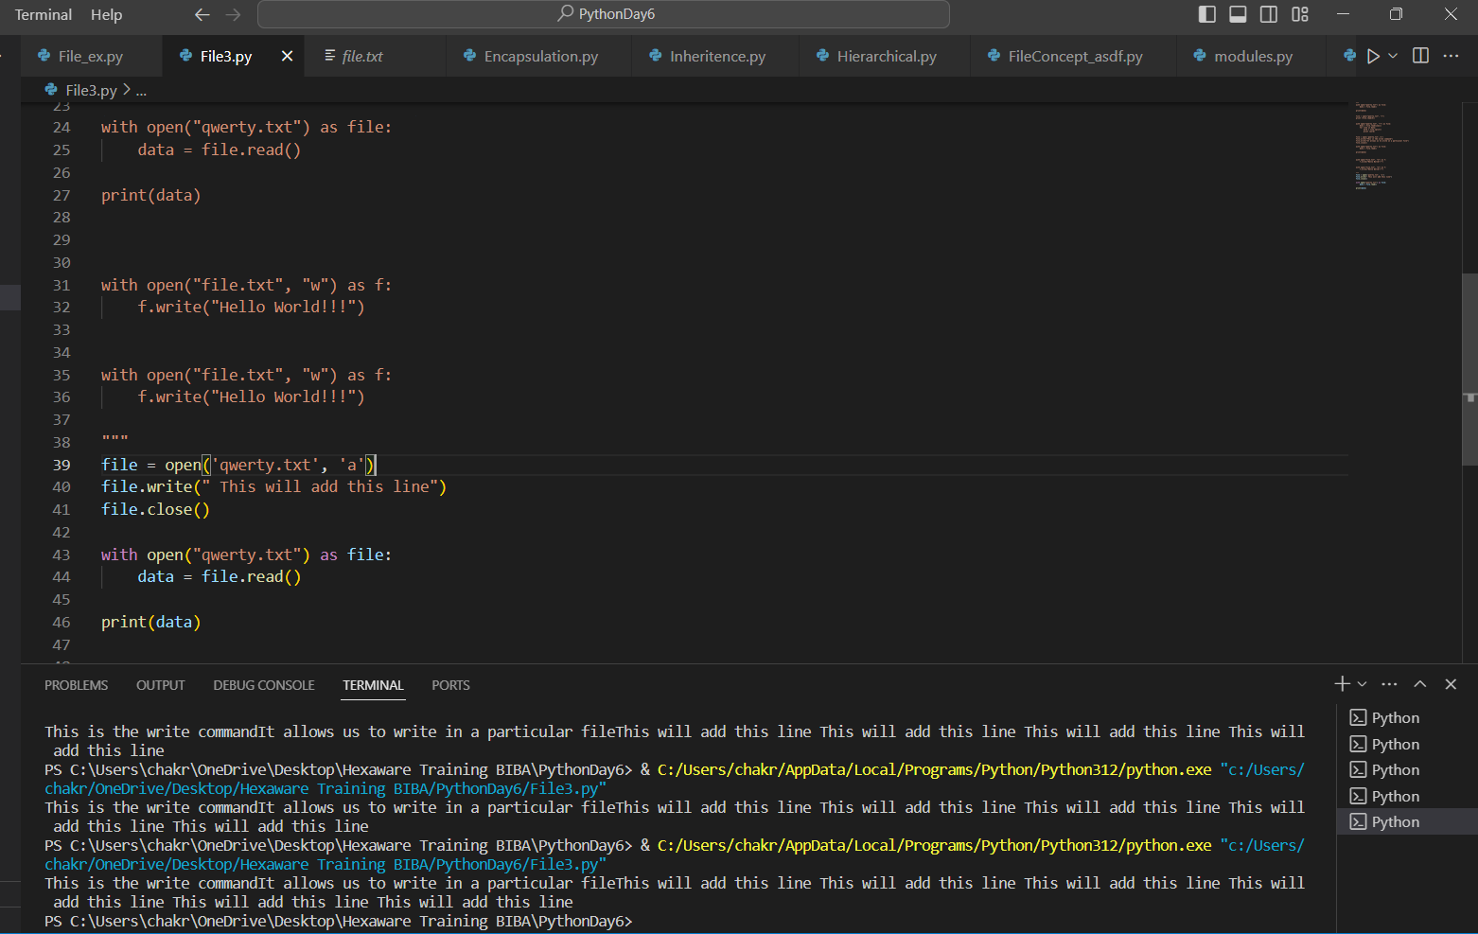

🡪Modules

Modules are the one, that has a huge no. of functions. Functions in the module can be accessed when ever we wanted.

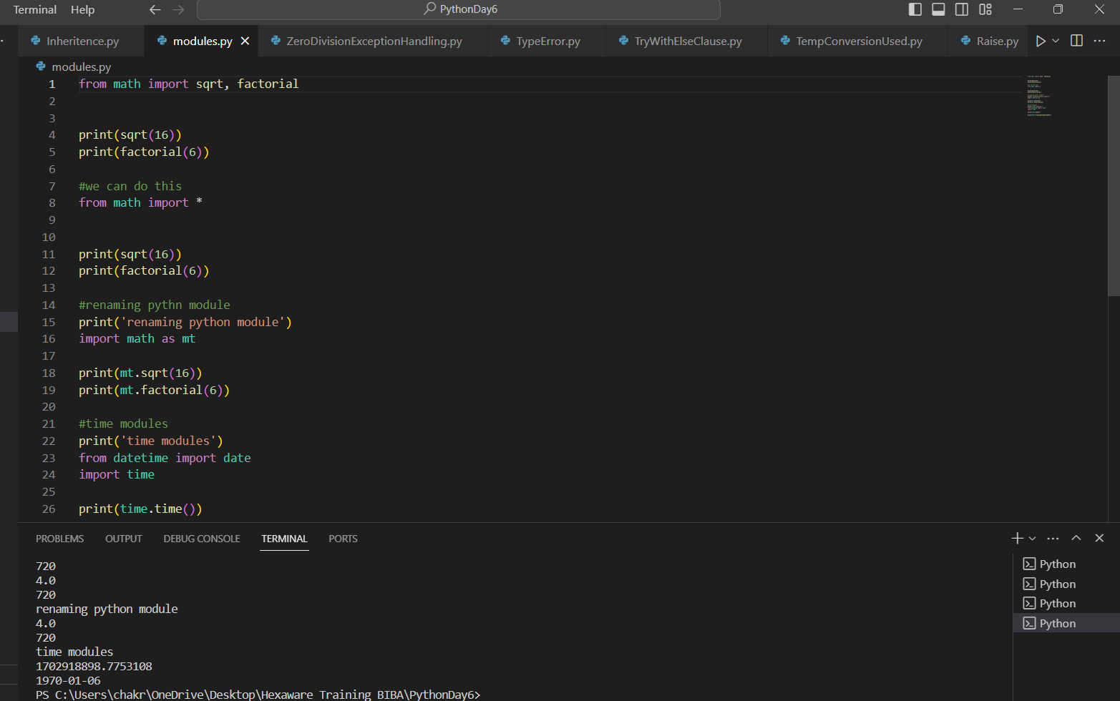

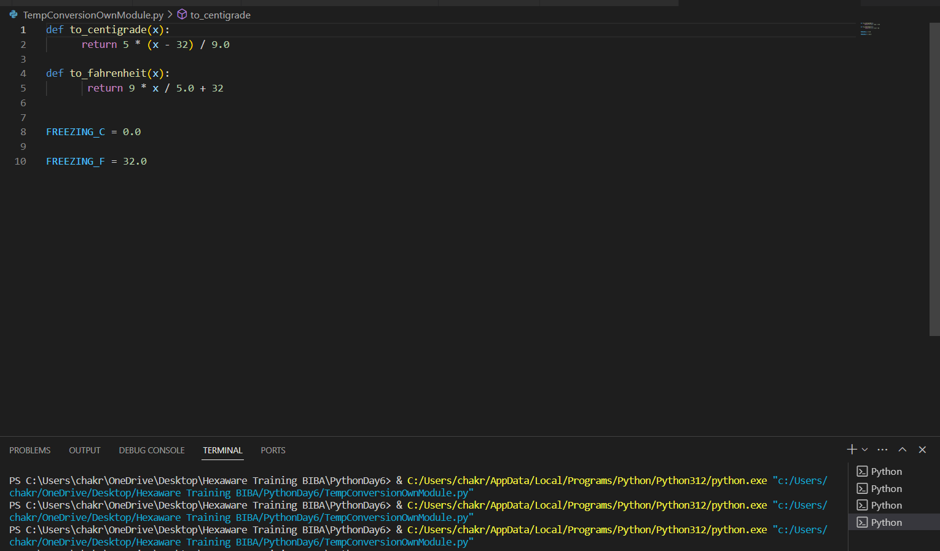

User Defined Modules

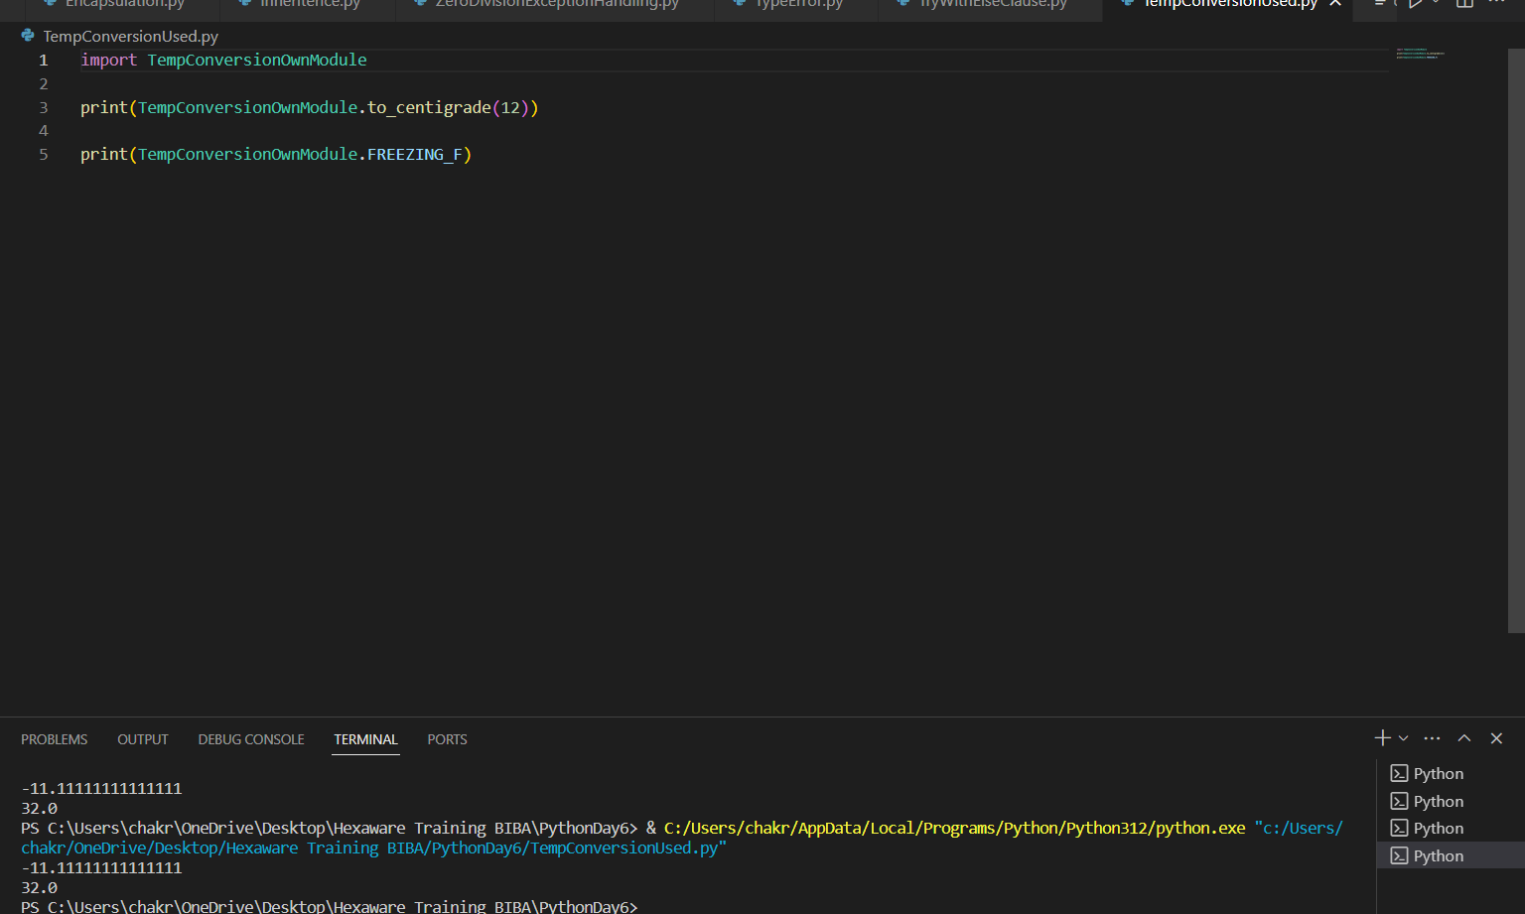

🡪Exception Handling

We use exception handling to handle the program for not throwing the errors.

Type error

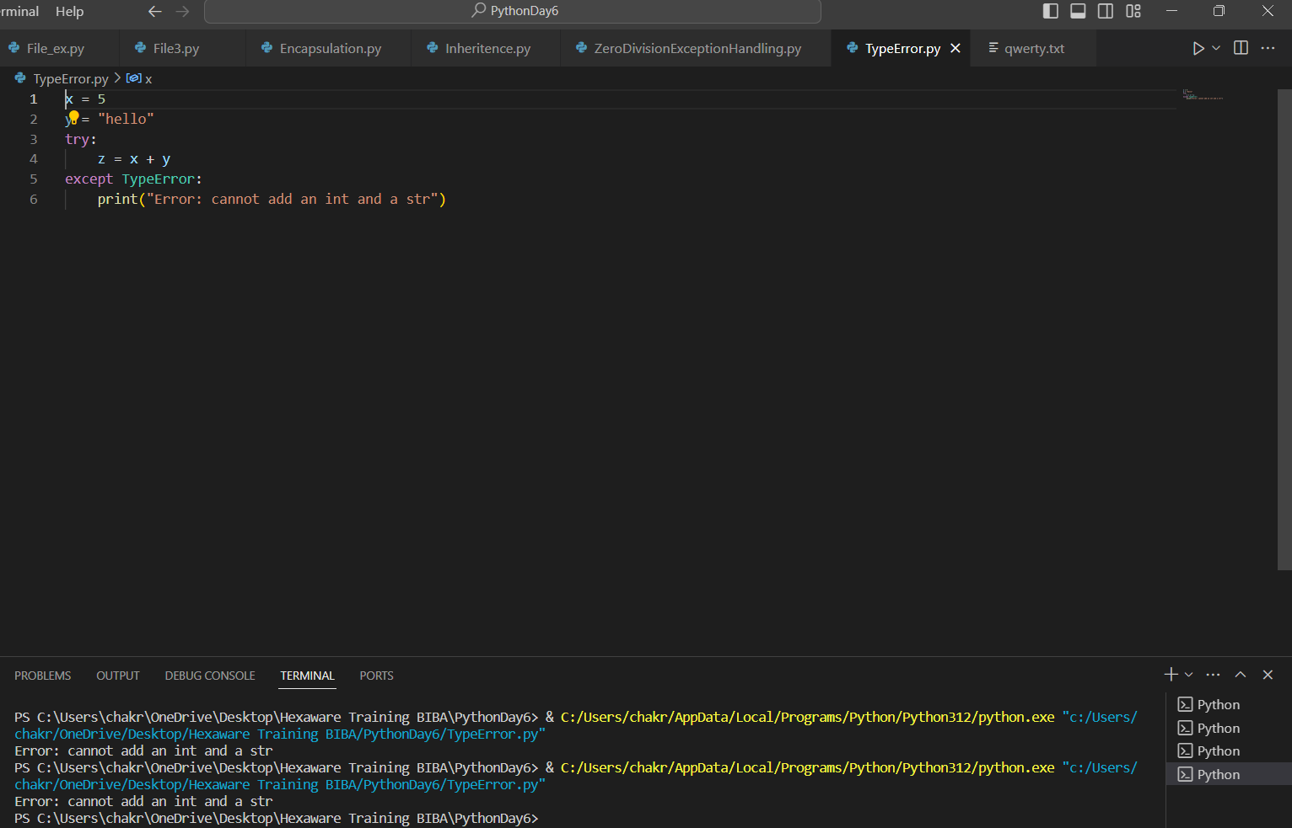

Zero division error 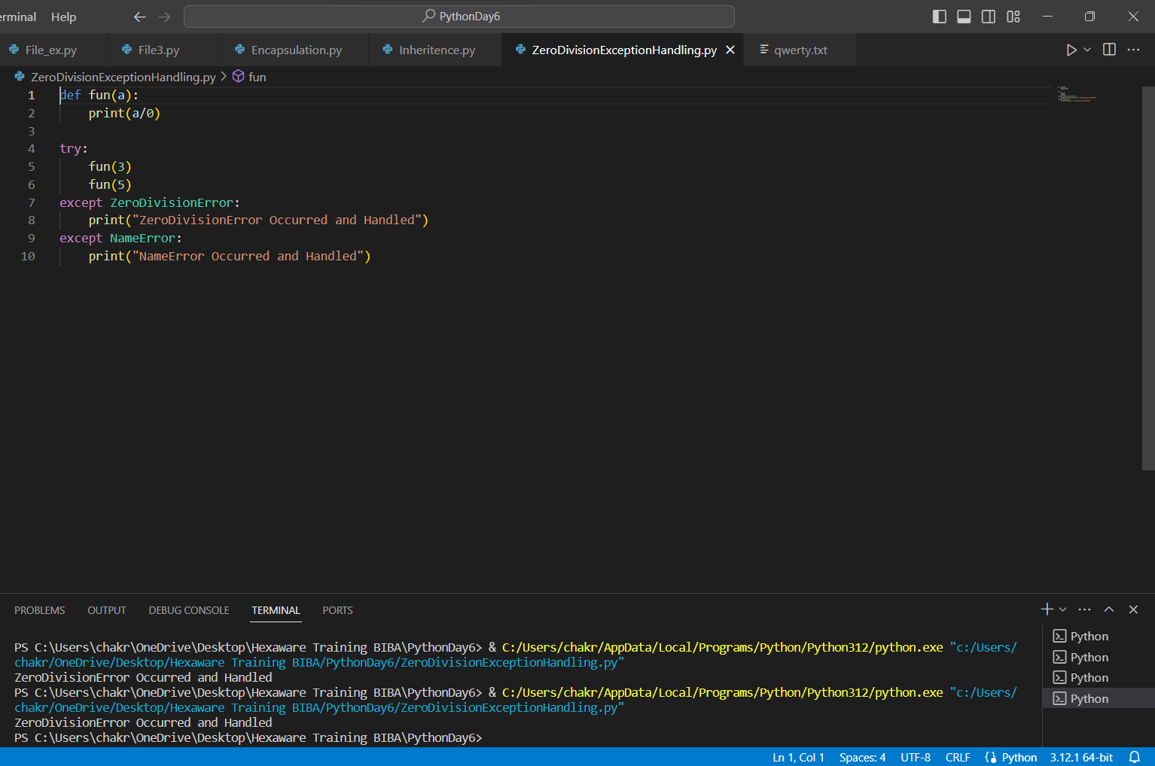

Try with else

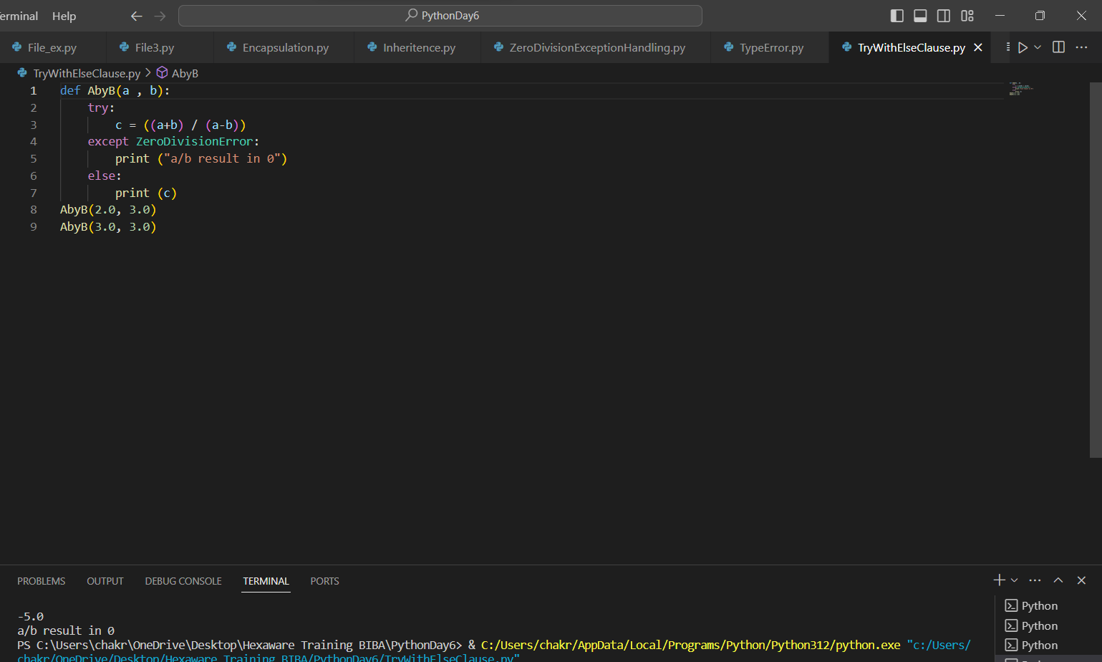

Finally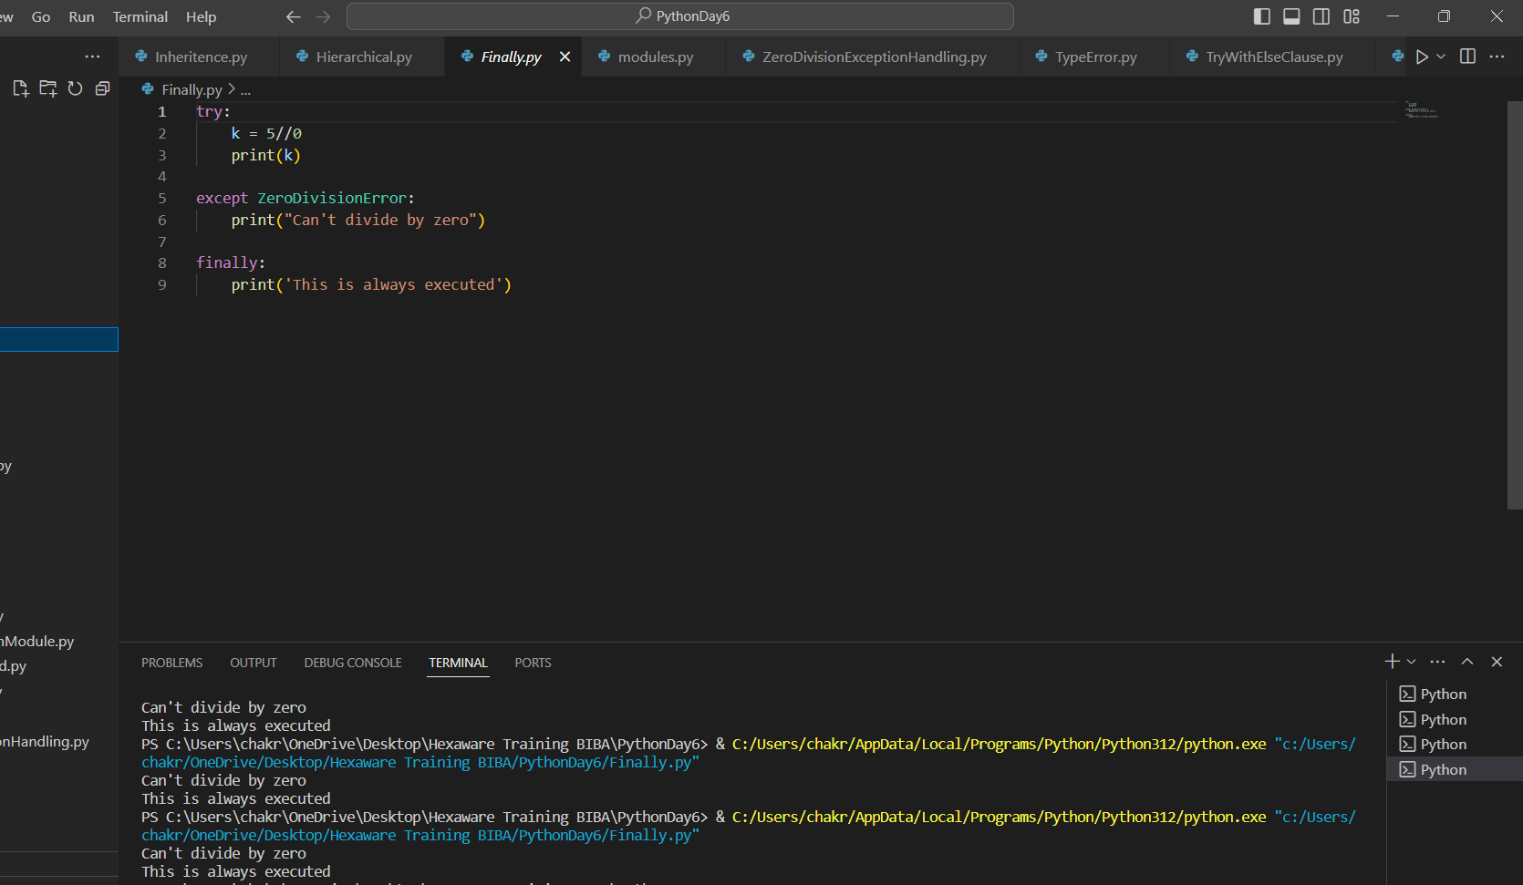

Raise

